Text Box Test Validation  
  
Screenshot : HomePage  
  
  
  
Screenshot : ElementPage  
  
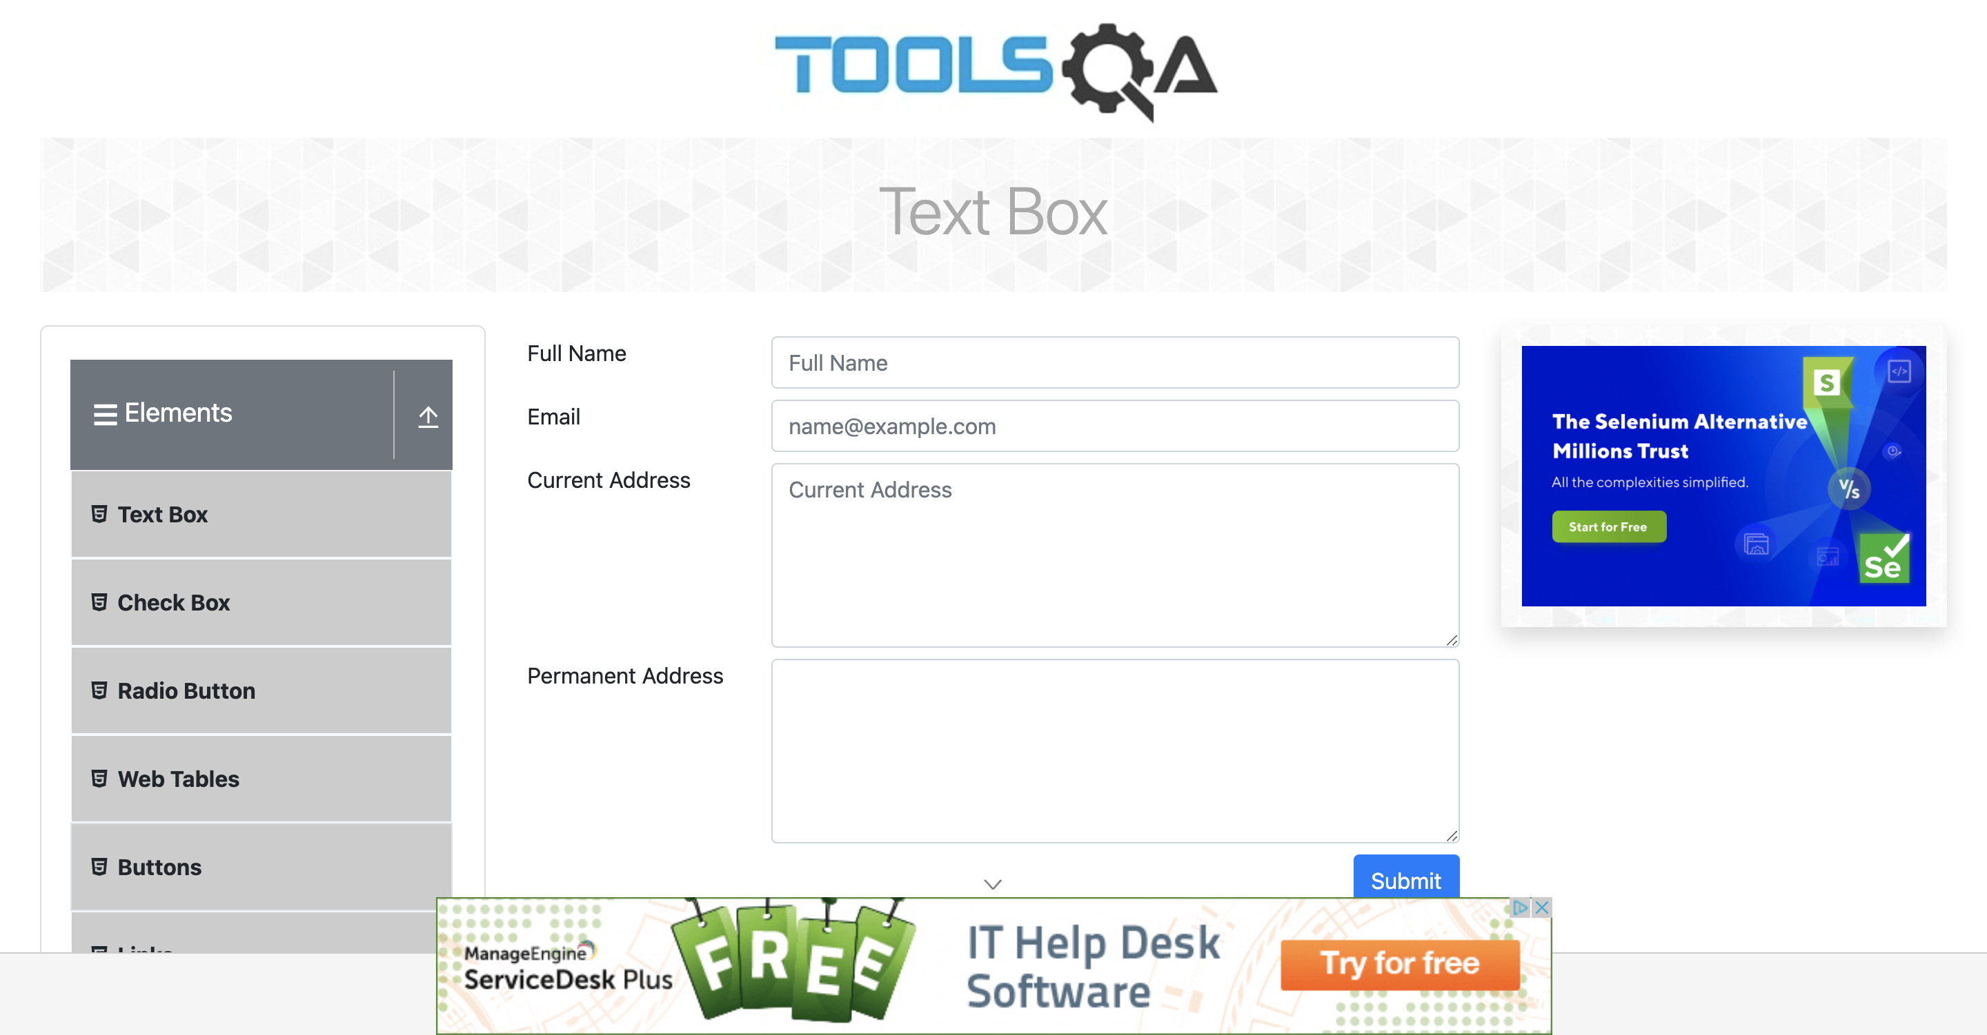  
  
Screenshot : TextBoxPage  
  
